Nathan deBar
CS-255
June 18, 2025

CS 255 System Design Document
DriverPass

UML Diagrams

UML Use Case Diagram
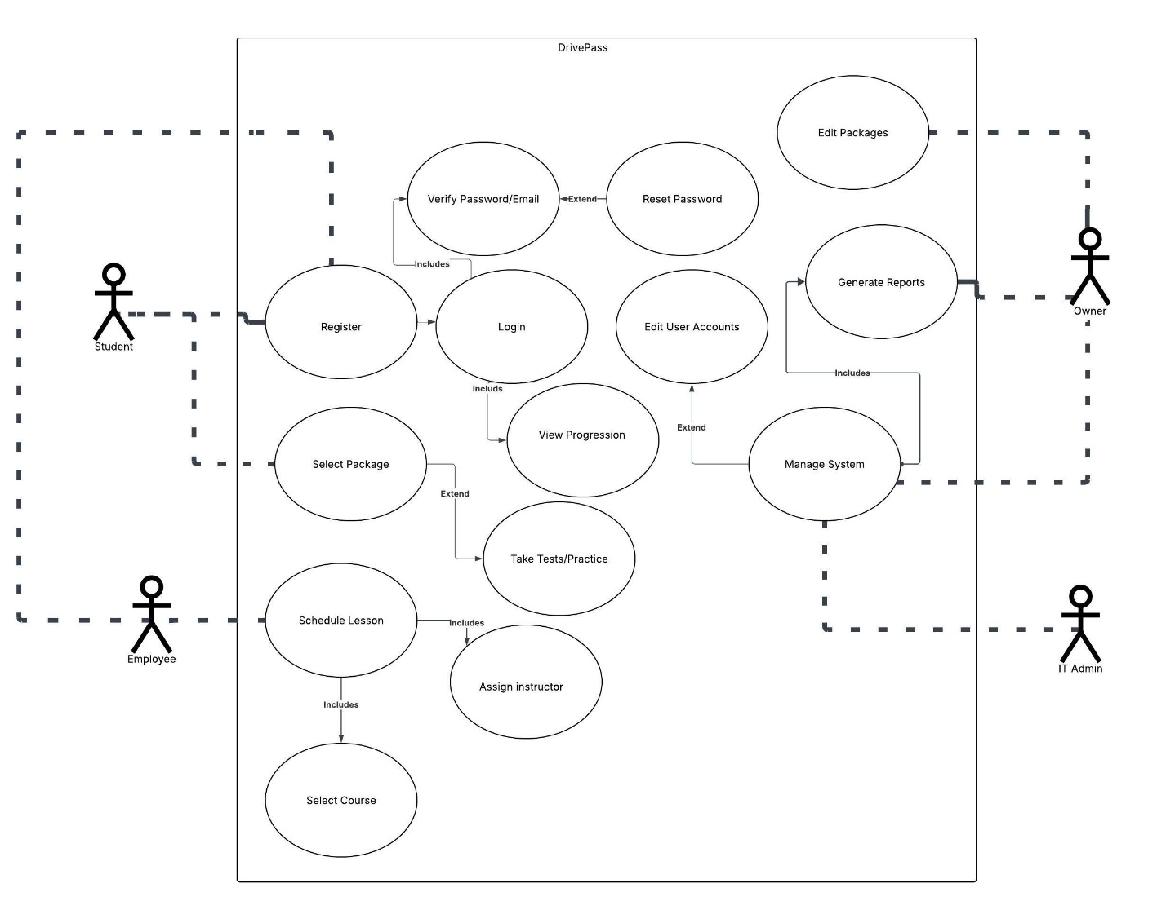

UML Activity Diagrams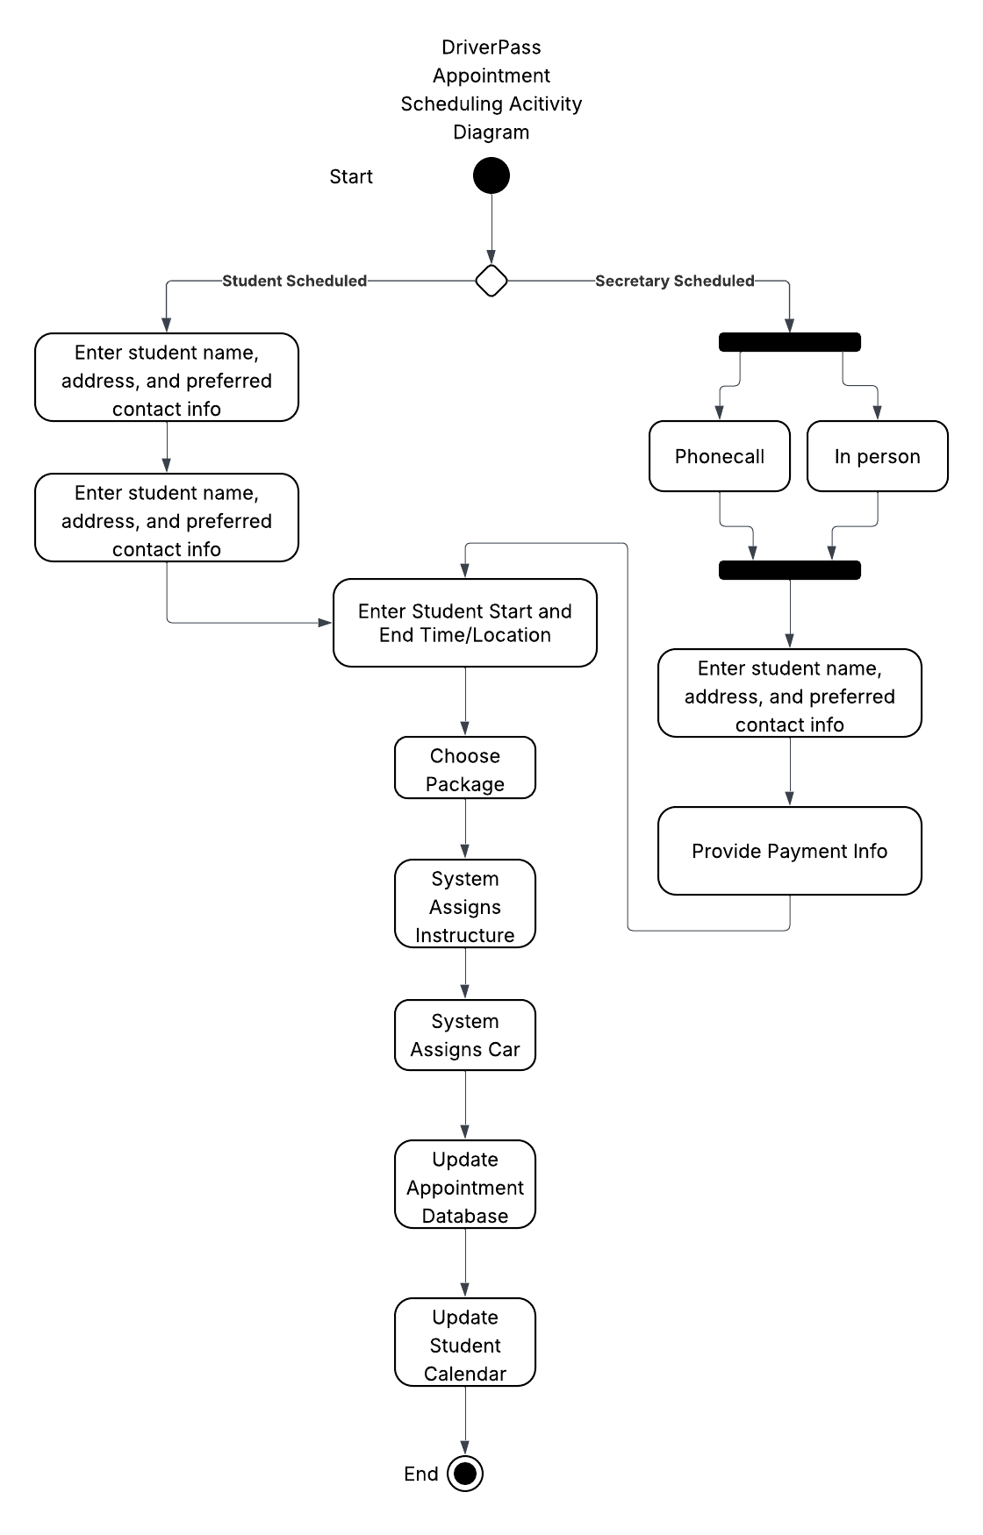
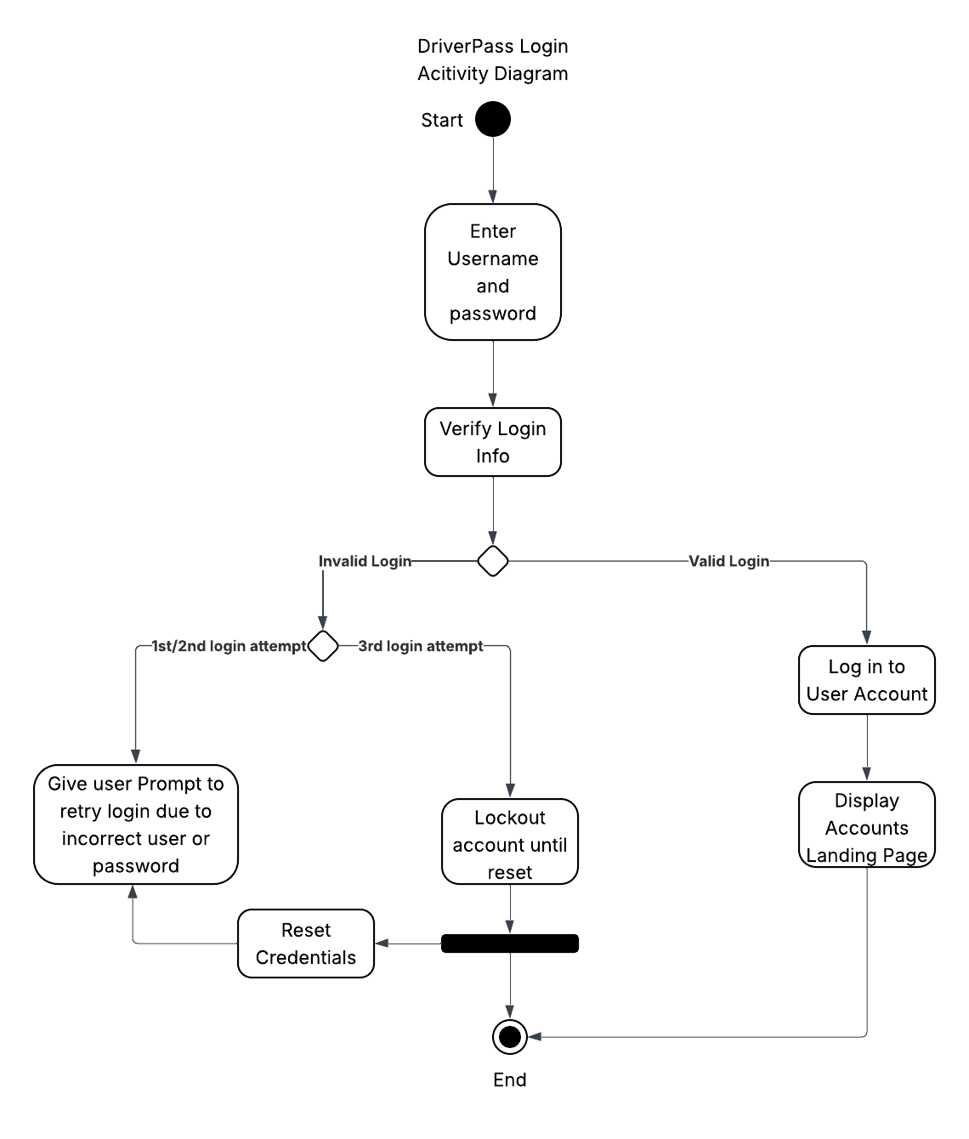

UML Sequence Diagram
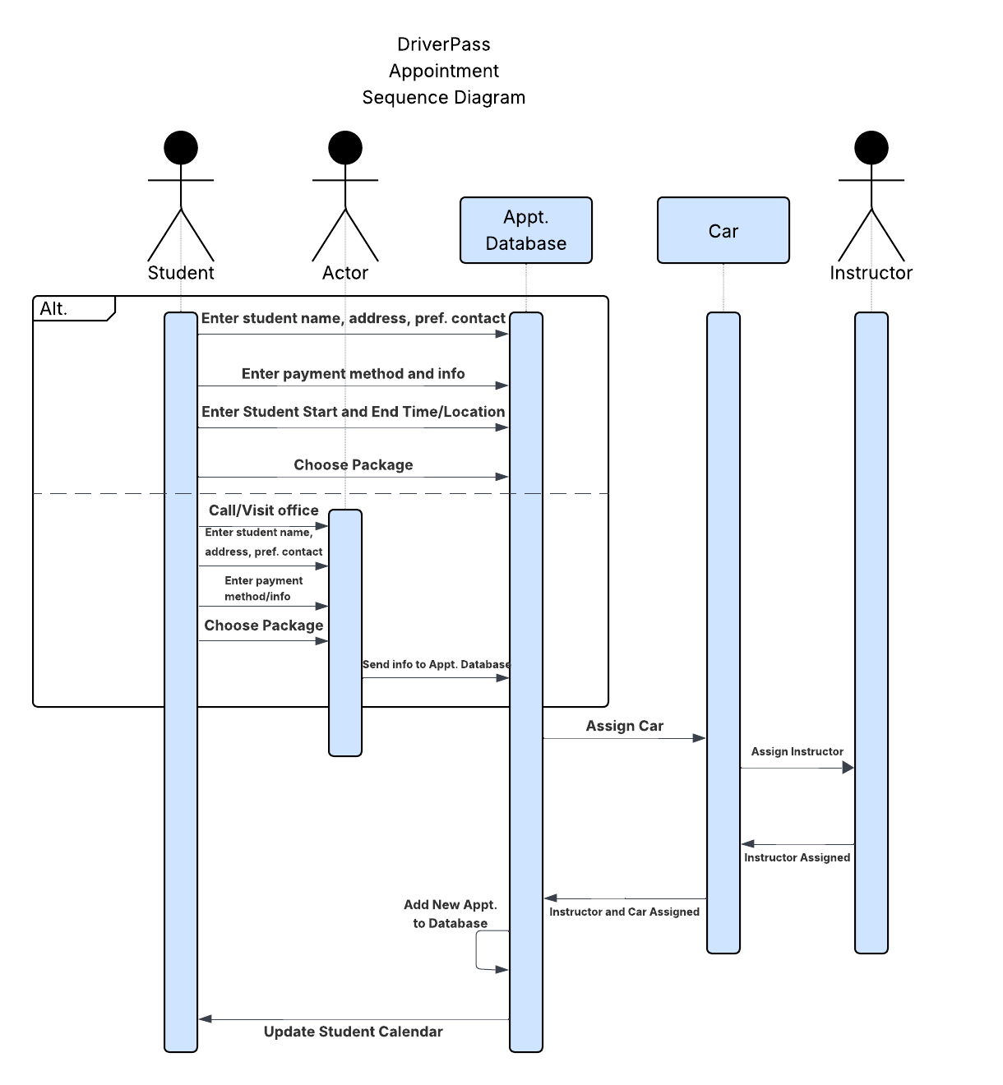

UML Class Diagram
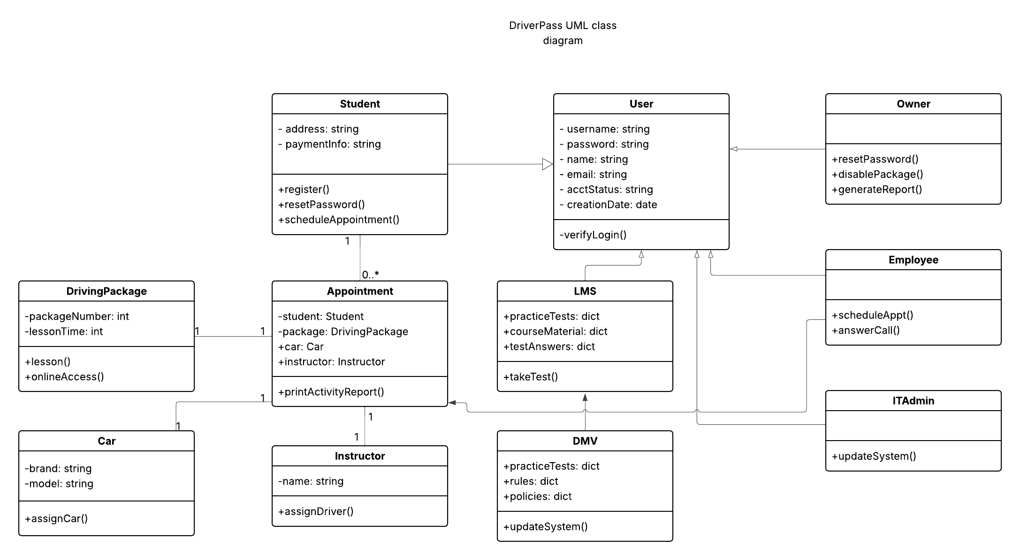

Technical Requirements

The system as discussed for the DriverPass system has a few technical requirements that must be fulfilled. Foremost the application must be accessed from the web as it is going to be hosted on a cloud-based server. The server will host both the application and a database that will store pertinent information for the users and the company. This includes the client’s personal information such as contact details, package choice, as well as the scheduling information for the instructor, drivers, and related DMV policy information to be used when creating tests. Additionally, there must be an online payment system setup such as Venmo, Square, PayPal, or Zelle so that users can pay for the selected packages. This is important because these third-party systems must be compatible with the DriverPass system.

